Project name: Cramer’s Rule calculator + Mysql Integration

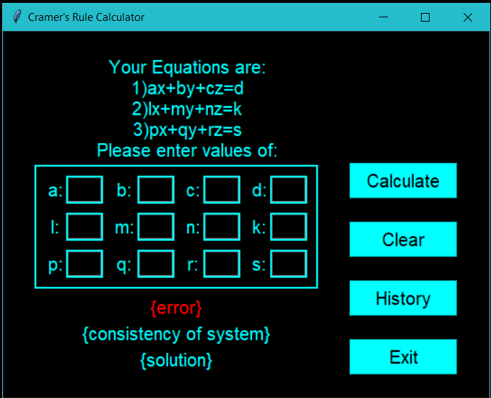By: Akshat Aryan and Merril Baiju

1. The text boxes will take input from user which will be the coefficients of the 3 variables in each of the 3 linear equations which will be stored

2. The calculate button will then find out the determinant of the variables which have been input and the value of det will be stored, and accordingly solution will be displayed, pressing it will also store the input and output as a table in mysql

3. The error label will mention error when invalid values are input

3. The first label will output whether or not the system is consistent or inconsistent depending on det value

4. The second label will output the answer if any unique solution, or will tell whether the system has infinite solutions or no solution

6. The clear button will clear all the labels and text boxes for the user to input new values

7. The history button will load up the mysql table where all the inputs and their solutions are being stored in 2 columns(This is the only integration of mysql database in this project)

8. The exit button will close the application.